Default the values to the select single
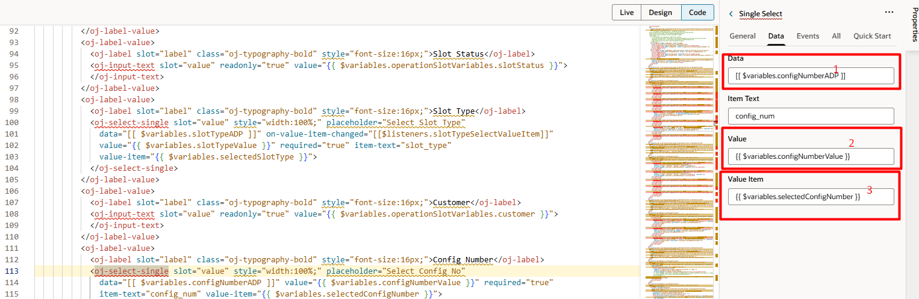
1. Edha use pani dhan lov la data varum
2. edhula dhan value set aghum
3. edhu dhan default value ku use pannuradhu

Variables eppadi dhan create pannum.
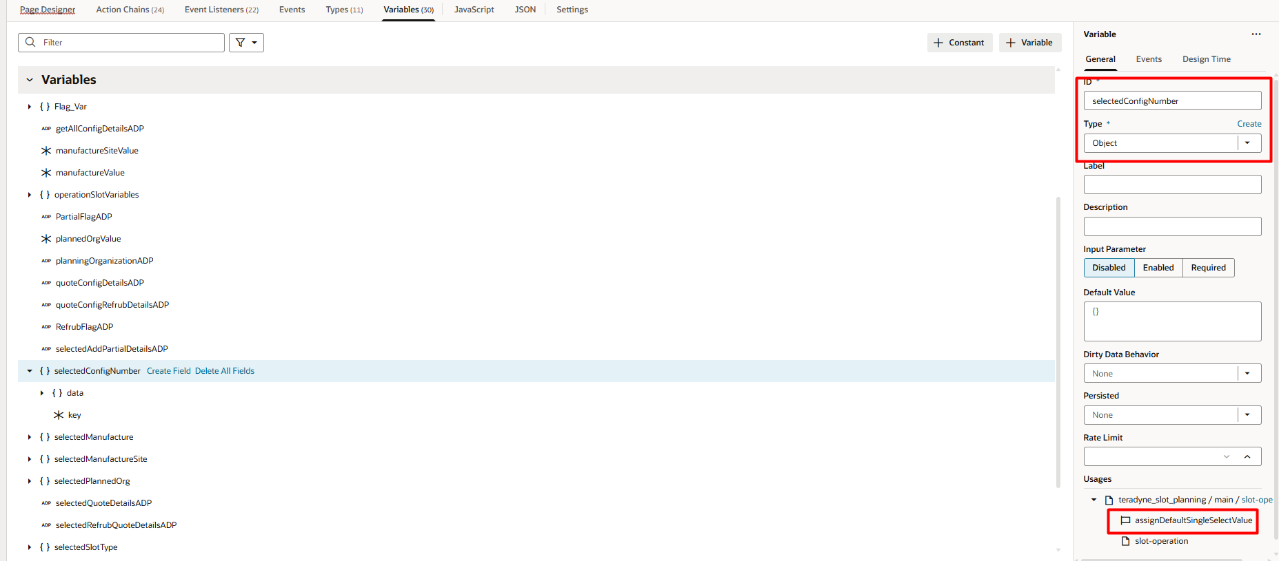

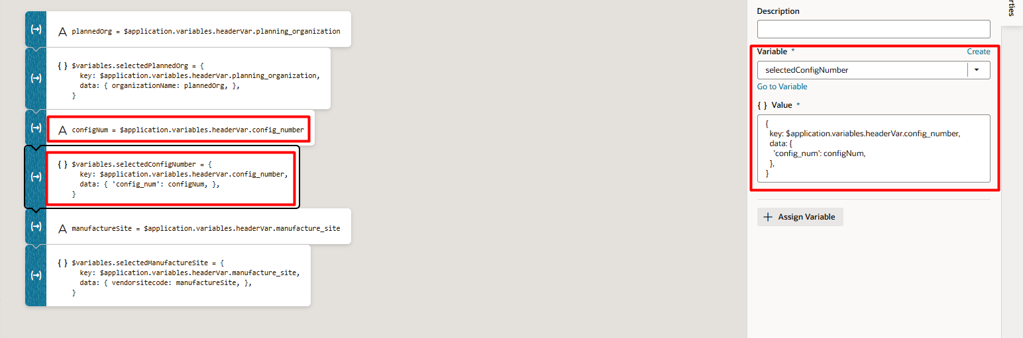
Our dummy variable create panni adhula endha data va poda porom ah adha assign panni erupan

Enga data la use panni erukuradhu ---- eg: config_num (adp liyum erukanum illana work aghaadhu )
Edhu eppadi work aghum na data adp la erukanum namba default panna pora data kandipa ah adp la erukanum … if adp la erundhu varum podhu data va varala namba default values vaichalum anga data display aghadhu so adp la erundhu select single ku data varanum appadi data vandha dhan namba vaichii erukura data default value ah set aghum adhuku andha rest service la erundhu vara outuput to adp la assign pannum vom l adhu kuda endha name liya ah eruakanum illa na varadhu .

